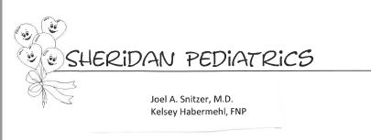
Sheridan Pediatrics is seeking a Pediatrician to join our practice, full or part-time. We are a relatively small, yet modern practice with a long history of well-regarded service to our patients. Our homey flexible atmosphere is our difference and our staff is experienced and dedicated, which makes for a pleasant work environment. Opportunity for early buy-in or buy-out is available and benefits include health insurance, 401K, and malpractice insurance. We are happy to informally discuss mutual needs with any interested Pediatrician.
We are located at 605 Grover Cleveland Hwy., Amherst, NY 14226, 716-836-3300.

