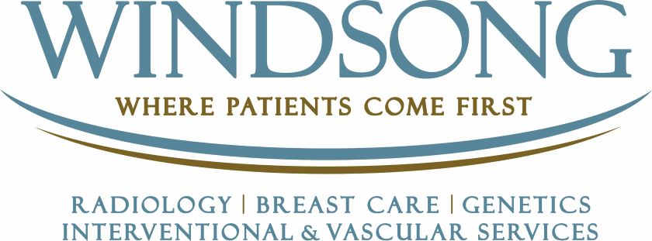
Radiologist- Breast Imaging
Discover Windsong…the premier free standing imaging outpatient centers and early adopters of the most advanced technology offering a multidisciplinary approach and patient centered care for over 35 years. Windsong Radiology is physician lead by a tight-knit partnership of world-class physicians who foster continued growth within the Western New York region.
We can offer you:
- Excellent work/life balance with no overnights or on-call.
- Flexible scheduling options to include on-site, teleradiology or hybrid.
- 100% outpatient focus.
- Competitive compensation and excellent benefits package (medical/dental/vision/401k/PTO/CME).
- Partnership or non-partnership track available.
- Established referral sources and outstanding reputation within the region.
- Low cost of living providing excellent schools, professional sports teams, array of arts and theatre, excellent shopping and dining venues, easy and quick access to Toronto and New York City.
We are a culture of firsts in Western NY when it comes to diagnostic radiology breast care services, serving as a market leader. Windsong was the first outpatient center in the country to earn accreditation from the NAPBC! As an imaging leader with a long history of excellence we continue to build upon our brand and long-standing stellar reputation within our community.
If you are a compassionate and dedicated Radiologist looking to join a team of fellowship trained physicians with entrepreneurial spirit and the desire to provide the best patient care, please consider joining Windsong Radiology.
Requirements:
- Completion of medical school, a medical internship, and medical residency in radiology at an accredited medical facility required.
- Board Certified
- Fellowship Trained

Send a resume/cv in confidence to Sandy Scheffler, sscheffler@windsongwny.com or visit windsongwny.com for more information.

