Primary / Urgent Care Clinic
For Lease or Sale

- 3,300 sq ft former VA Clinic
- 4 exam rooms with plumbing
- 4 Bathrooms
- X-ray Room and Laboratory
- 5 Offices, Reception, Electric Doors
- Physical Therapy Area / Conference Room
- Ample Parking on 2 acres
- Fully Handicap Accessible to Federal Guidelines

Central Location
Next door to Sav-A-Lot and Family Dollar

166 East 4th St.
Dunkirk NY

$15 NNN Lease or
$750k Sale includes $35k current income

Call Owner for more information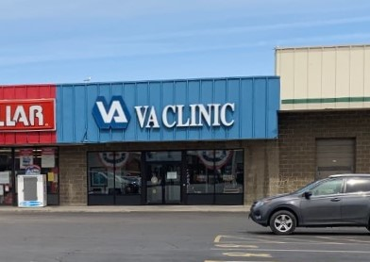
Geoff Jenkins
917-825-4542
geoff_jenkins@hotmail.com

